Republic of the Philippines

National Police Commission

Philippine National Police

**Cavite Police Provincial Office**

**CARMONA MUNICIPAL POLICE STATION**

Brgy Maduya, Carmona, Cavite

***carmonacavitepnp@gmail.com***

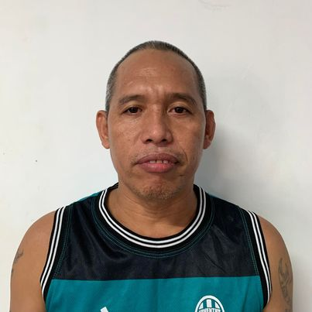

April 5, 2022

**CERTIFICATE OF DETENTION**

**TO WHOM IT MAY CONCERN**

**THIS IS TO CERTIFY** that one **GARRY PANOPIO MIRANDA**, male, 45 years old, born on **June 10, 1976**, married, resident of **Sitio Davilan, Lantic, Carmona, Cavite** was detained at this office since December 16, 2021 up to present and charged for the crime of **“Murder”** with Criminal Case Nr. **B-2015-858,** before the Office of Provincial Prosecutor, Imus, Cavite.

This certification is being issued upon request of interested party for whatever legal purposes it may serve.

Prepared by :

Garry Miranda, **PSSg Anderson A Videña**

Detainee Custodial Officer